**Unit 4: Assignment**

1. **What is the difference between AC servo motor and DC servo motor?**

| **AC Servo Motor** | **DC Servo Motor** |
| --- | --- |
| Operates on AC power supply (alternating current). | Operates on DC power supply (direct current). |
| Uses AC synchronous or induction motors for precision control. | Uses DC motors, typically a permanent magnet or wound field motor. |
| Stator creates a rotating magnetic field and rotor follows it. | Rotor rotates due to the magnetic field generated by the stator and brushes. |
| Requires feedback system (e.g., encoder) for position and speed control. | Uses commutators and brushes for rotation control, providing smoother operation in lower-speed applications. |
| Higher power and efficiency at higher speeds. | Better torque at low speeds. |
| Preferred for higher precision and high-performance applications. | Used in lower-cost and simple applications. |

**2. Explain the construction and working principle of a DC servo motor with diagram and Applications.**

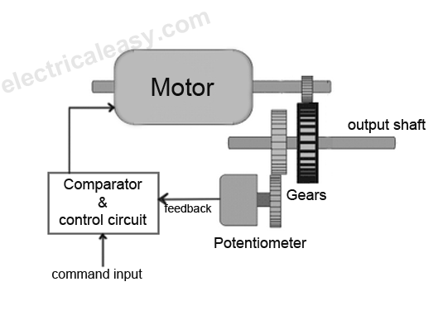**Construction:**

* **Stator**: The stator consists of a permanent magnet or field windings that produce a stationary magnetic field.
* **Rotor (Armature)**: The rotor is a coil of wire that rotates inside the magnetic field. The armature is connected to a shaft.
* **Commutator and Brushes**: These are used to reverse the direction of current in the rotor windings, ensuring continuous rotation.

**Working Principle:**

* A DC supply is given to the stator.
* The current in the armature winding creates a magnetic field that interacts with the stator field, resulting in torque and causing the rotor to turn.
* The commutator reverses the current in the windings as the rotor turns, maintaining continuous motion.
* The feedback system ensures precise positioning and speed control.

Applications:

* Robotic arms, automated control systems, servo-controlled mechanisms, and precision positioning systems.

**3. Explain the construction and working principle of an AC servo motor with diagram and Applications.**

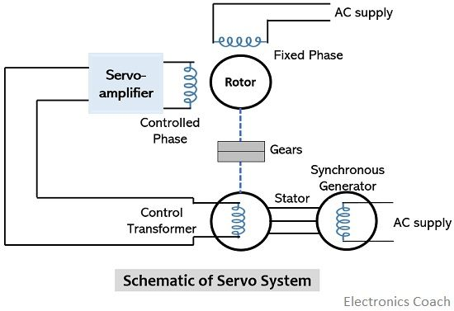**Construction:**

* **Stator**: The stator has **two windings**: a **main winding** powered by a constant AC supply, and a **control winding** powered by a variable voltage to control the rotor's position.
* **Rotor**: The rotor may be either a **squirrel-cage** or **drag cup** type, both made of conducting material that interacts with the stator's magnetic field.

**Working Principle:**

* The **main winding** produces a **constant magnetic field**.
* The **control winding** produces a **rotating magnetic field** due to the variable voltage supplied to it.
* The **rotor** follows the rotating field and **aligns** itself with the changing field, causing it to rotate.
* The position of the rotor is continuously adjusted based on the error signal from the feedback system, ensuring precise control.

**Applications:**

* **Robotics**, **CNC machinery**, **automation systems**, and **high-precision control applications**.

**4. Explain the construction and working of a permanent magnet type stepper motor with diagram and Applications.**

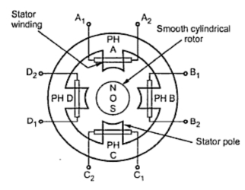**Construction:**

* **Stator**: The stator has **electromagnetic coils** wound around it to create a magnetic field.
* **Rotor**: The rotor is a **permanent magnet** that interacts with the stator's magnetic field.
* **No Brushes**: There are no brushes, as the rotor is moved by a step-by-step change in the magnetic field of the stator.

**Working Principle:**

* The **stator coils** are energized in sequence, generating a **magnetic field** that attracts or repels the rotor's permanent magnet.
* The rotor **rotates step by step** as each coil is energized, aligning with the magnetic field of the activated stator coil.
* **Full rotation** is achieved through the sequential energizing of coils, which ensures precise control.

**Applications:**

* **Printers**, **discs drives**, **scanners**, **robotics**, and **precision positioning systems**.

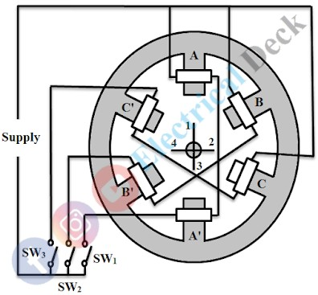**5. Explain the construction and working of Variable reluctance type stepper motor with diagram and Applications.**

**Construction:**

* **Stator**: The stator has **electromagnetic coils** wound around it to produce a magnetic field.
* **Rotor**: The rotor is made of **soft iron** and has multiple **teeth**.
* **No permanent magnets**: The rotor relies on the **magnetic reluctance** principle.

**Working Principle:**

* The **energized stator coils** generate a magnetic field that **attracts the rotor's teeth**.
* The rotor moves to the position where the reluctance is minimized (where the teeth of the rotor align with the magnetic field).
* The rotor moves step by step as coils are energized sequentially.
* The rotor's movement is determined by the **minimization of reluctance**.

**Applications:**

* **Computer disk drives**, **positioning systems**, **industrial automation**, and **low-cost motion control systems**.

**6. Explain the construction and working principle of a BLDC motor with diagram and Applications.**

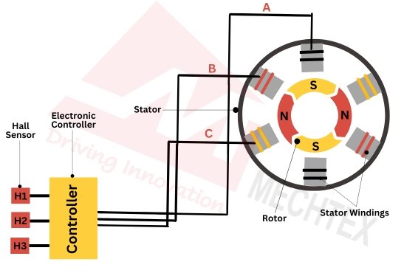**Construction:**

* **Stator**: The stator has **three-phase windings** wound on a laminated core.
* **Rotor**: The rotor is made of **permanent magnets**.
* **No Brushes**: There are no brushes for commutation, and **electronic commutation** is used instead.

**Working Principle:**

* The **stator windings** are powered by **three-phase AC** current, creating a rotating magnetic field.
* The **rotor**, made of permanent magnets, follows the magnetic field of the stator.
* The position of the rotor is continuously sensed by a **Hall effect sensor**, and the **electronic controller** switches the current to the stator windings at the appropriate time to keep the rotor turning.
* The motor operates efficiently without the friction caused by brushes.

**Applications:**

* **Electric vehicles**, **drone motors**, **fans**, **computer cooling fans**, and **industrial machinery**.